Vouchering in a Virtual World – WSACA Finance Conference 2021

Nothing changed for us as far as coming in to the office during the closure.

Douglas County operates in a hybrid paperless AP system and has for the last 8-10 years. Prior to that, it was strictly paper with physical signatures on all invoice approvals. As the AP Tech operate in 3 different roles and each role has its own unique login to the AP system for workflow and tracking purposes. Roll 1 - I am a submitter of invoices for the county, roll 2 – I am a final approver of all input invoices and roll – 3 I enter invoices for all the taxing districts.

We also have electronic voucher approvals within the workflow to help speed up the voucher approvals. Some of the departments have 2 levels of approval (such as the supervisor/manager and then the final approval) and some have only 1 (the final approval). All vouchers get a final approval where all of the information is verified (sometimes for the second time) and the backup documentation is double-checked.

In one of my roles (AP Submitter) – I do the initial entering of the voucher into the AP system. We use FMS III and that is a product from Mitchell Humphrey. This is the main screen where the vendor, document ID (invoice number), description of the invoice and the amount are entered. Once all that information is entered, the BARS information is entered under the account field.

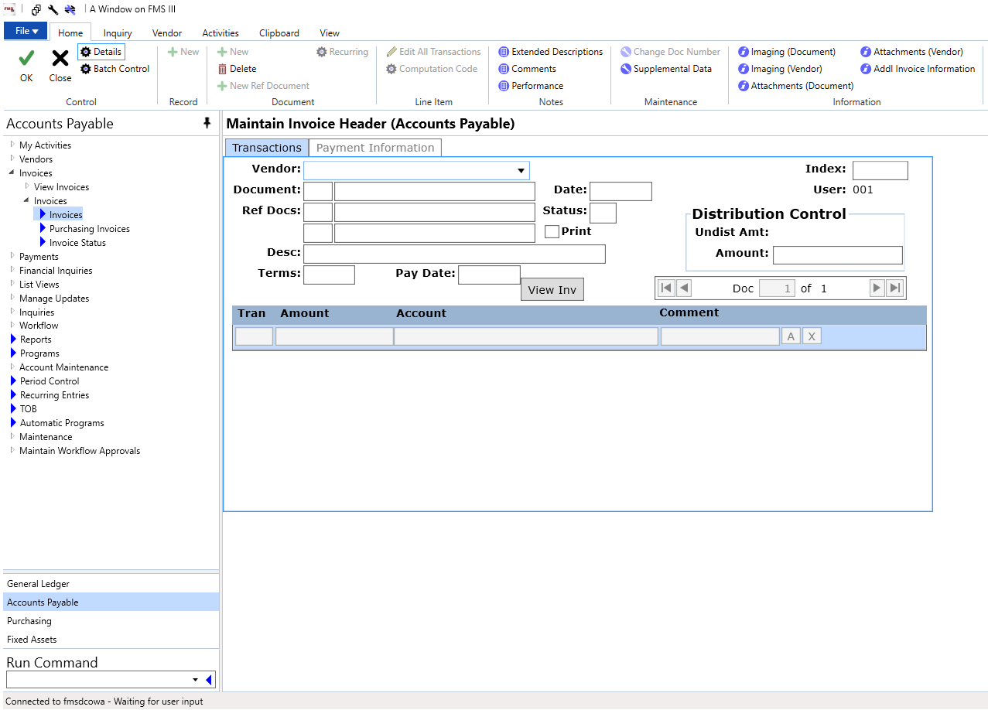

Once all that information is entered, the PDF backup is attached. The PDF is just a ‘blip’ on the server and doesn’t take up much room.

This is the screen where I attach the electronic backup (a PDF). We use INVOICE as the description on this screen, select AP Invoice, browse for the file and click ADD.

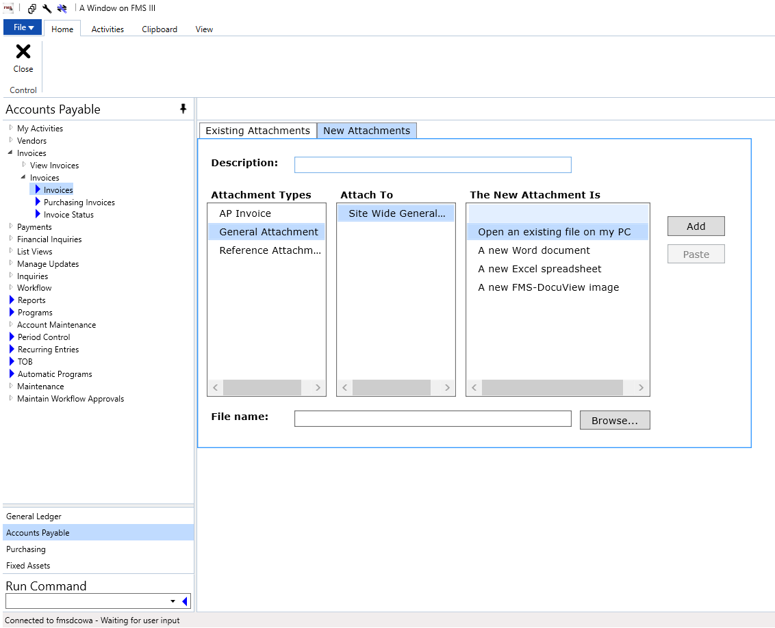

Once that is done. I route it to the appropriate person/department for approval. The approval routing path is established in workflow system.

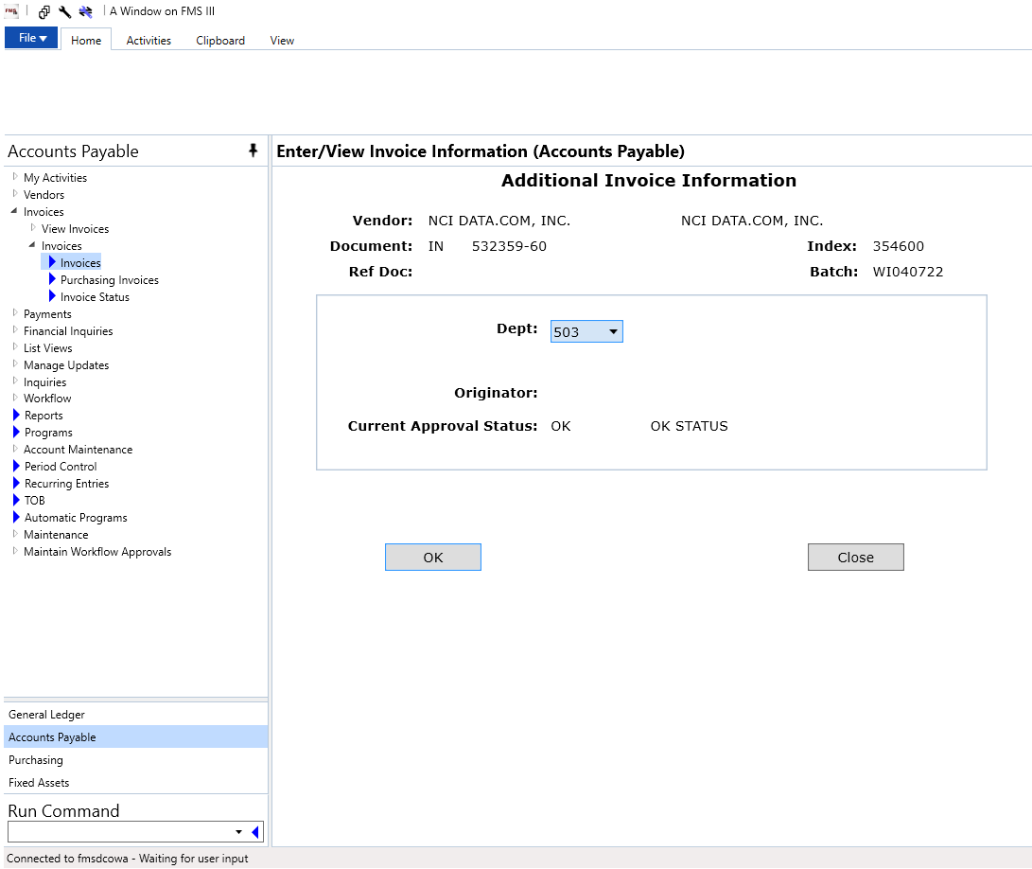

This is an example of a workflow for Department 503 (MIS Dept). The submitter is not listed on this workflow.

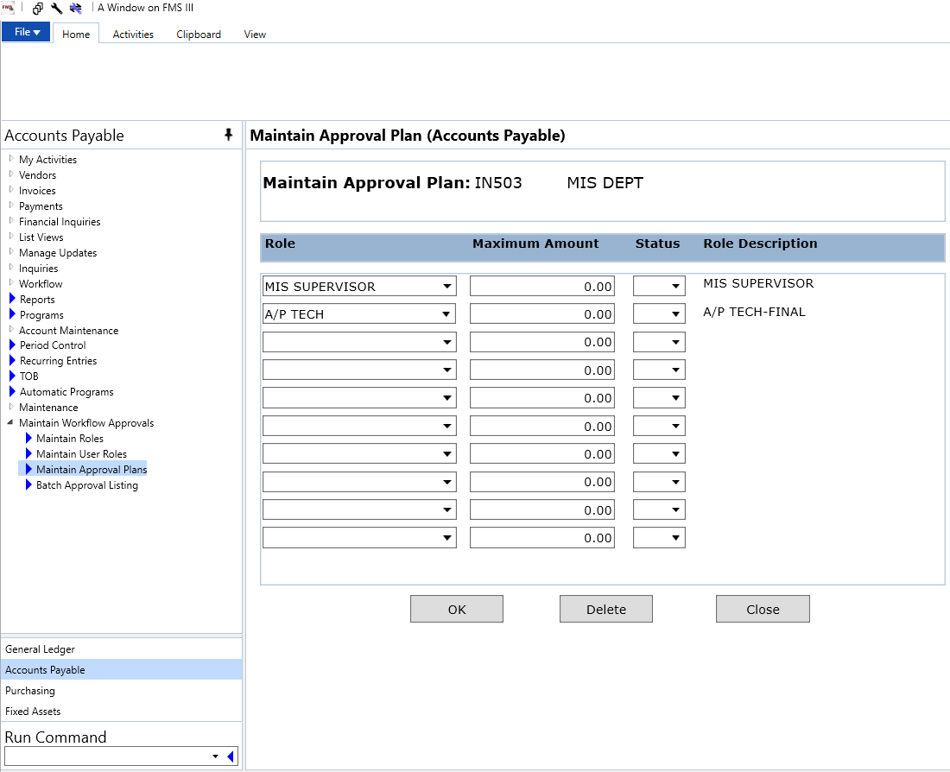

Here is an example of a workflow that has a submitter in it. This one is set up for when the AP Tech may need to help out and fill in when the regular person who enters the invoices is out.

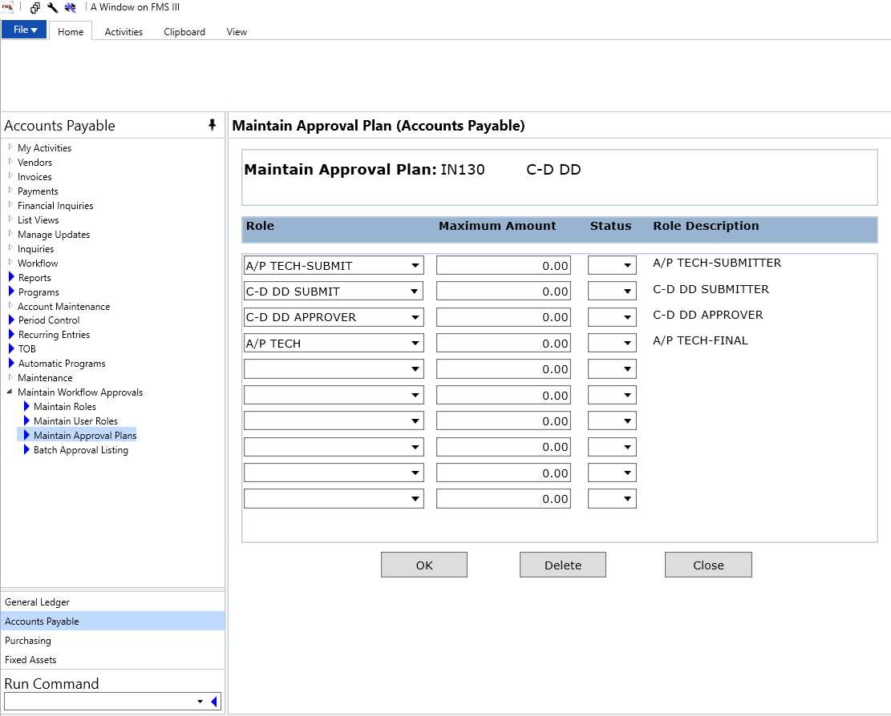

In the submitter role, I enter invoices for the Auditor’s Office,Maintenance, MIS and Land Services/Public Works. For the Land Services weekly invoices, I do an upload into FMS from the accounting system that they use. They use WinCAMS and at this point they still use all paper with hard signatures on all of the invoices that are being processed and approved. I do attach a PDF for backup in WinCAMS, and we could probably go semi-paperless with only needing one hard signature on the voucher approval recap but at this point it will still be as it is.

The other departments (such as the Treasurer’s Office, Assessor’s, Clerk, Solid Waste, etc) enter their own invoice/voucher information, attach the electronic backup (PDF) and route it through the workflow system. The departments usually keep their physical records for a year then they are tossed. Occasionally I will help out another department and enter their information and route it to where it needs to go.

A nice feature for having electronic approvals/signatures is that within the workflow system, there is an electronic footprint of all the activity for each of the vouchers. It will show who entered the voucher initially and who approved it. It will also show if it was unapproved or sent back to the submitter for any reason. Every action is time and dated stamped. We are able to run an inquiry and see the workflow footprint if there are any concerns on a particular invoice.

In the second role that I have in the AP process, that is the ‘final approver’ role. That is where all of the vouchers for that week are reviewed, verified, the BARS coding is checked and making sure the attached backup is there and correct. At this point, if there are any remittance slips that are needed, those can be printed from the attached PDF. Otherwise, none of the backup is printed. I verify and balance once the Current Expense department invoices have had the final approval in FMS, then I upload the WinCAMS invoices into FMS and verify and balance again. If there happens to be an issues it can be isolated easier I feel if things are balanced before the upload is done.

The final approval process is done on Monday mornings. Once all the vouchers are reviewed and have had a final approval, a prepayment report is printed for the Board of Commissioner’s to review and sign.

For the third roll - I also enter the taxing districts vouchers for their payables but they are responsible for their paperwork and retention policies. They just send me a sheet that states basic information: the vendor, voucher or invoice ID, the purpose/description and the amount. We are just the ‘processors’ for their payables and try to keep it simple.

If needed for audit requests, public records requests or other reasons, we can access the information from the payables system and get hard copies for the documents.

I feel that the hybrid system works well for us since the county seat is in Waterville and has the majority of the departments there and I operate out of the East Wenatchee area and that houses on the same campus Land Services, District Court and the Sheriff’s Office. We all work closely even though we are spread out.

